Today is Monday by Eric Carle (Puffin Books 1996)

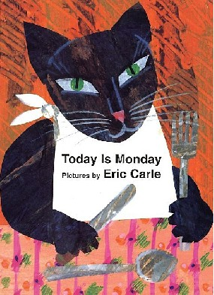

Age 6+
Note : there are no numbers on the book pages. Number them before you start so you can follow the page references below!
Language objectives:
Vocabulary – days of the week,
food vocabulary- peas, spaghetti, soup, meat, fish, chicken, icecream
animal vocabulary- hedgehog, snake, elephant, cat, duck, fox, monkey
Grammar- present simple – ‘eats’

Equipment
Children need scissors. One photocopy each of the animals and food.

Stages
1 Children work in pairs.
2 Each child makes a pocket book and numbers the pages and back cover 1-7
3 Write the days of the week on the board.
4 Help children copy them one onto each page of their mini books.
5 Children cut the photocopy in half. One child takes the animals and one takes the food pictures. They cut their pictures up and mix them on their desks
6 Read the story and children stick the animal/food in their books under the right word. The animal should go at the top of the page and the food on the bottom.
7 Children ‘read’ the story to each other in pairs using their books as you tell the story again.
8 Read the story again. This time children stick the missing pictures in their books.
9 Children in pairs tell the story to each other.

